

Mirage 3500 – Installation tips:

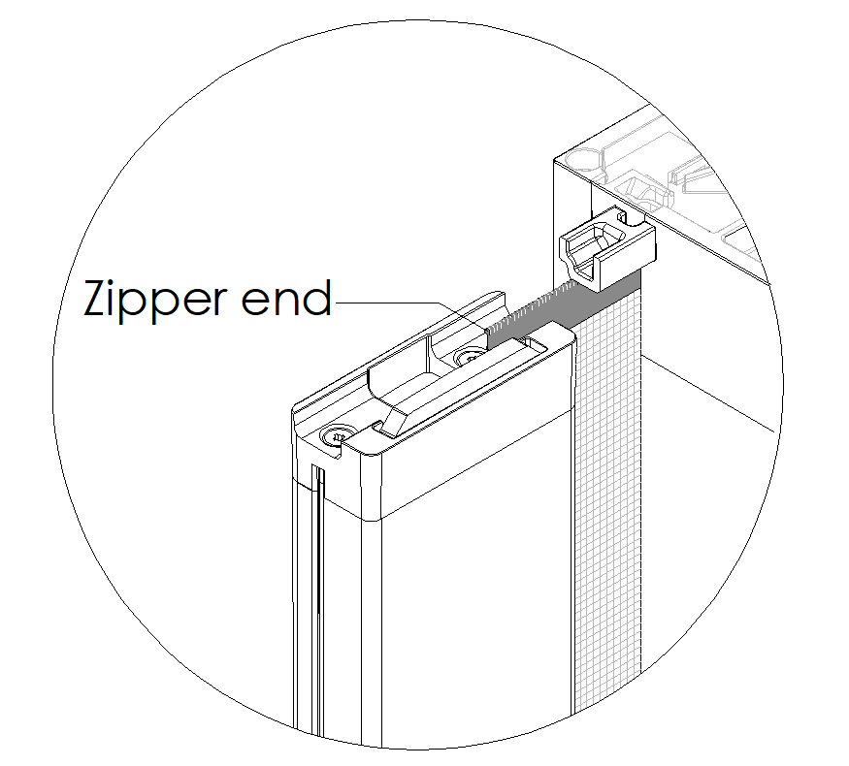
- Protecting the “leading edge” of the zipper - There is ½” of zipper end visible in the top and bottom pull bar guide - be careful not to bend or damage this zipper as it is the start of the “feed” into the track. See image at right.
- Unspooling the mesh after installation – Once you have the unit and tracks installed, slowly pull out the pull bar, one foot at a time and then retract it back, then pull out another foot. By gradually pulling the pull bar across the opening, it allows the zippers to properly stack inside the housing. Note: Never pull the pull bar out of the housing when it is not installed and, in the tracks, as retracting it back into the housing can be difficult.
- Increasing & decreasing tension – Tension level of the screen can be adjusted by removing the two small screws in the housing cap at end of the unit. The end to do this at is where there is a hexagonal cavity in the center that accommodates a ¼” Allen wrench. Turning the Allen wrench clockwise increases tension, counterclockwise decreases tension.
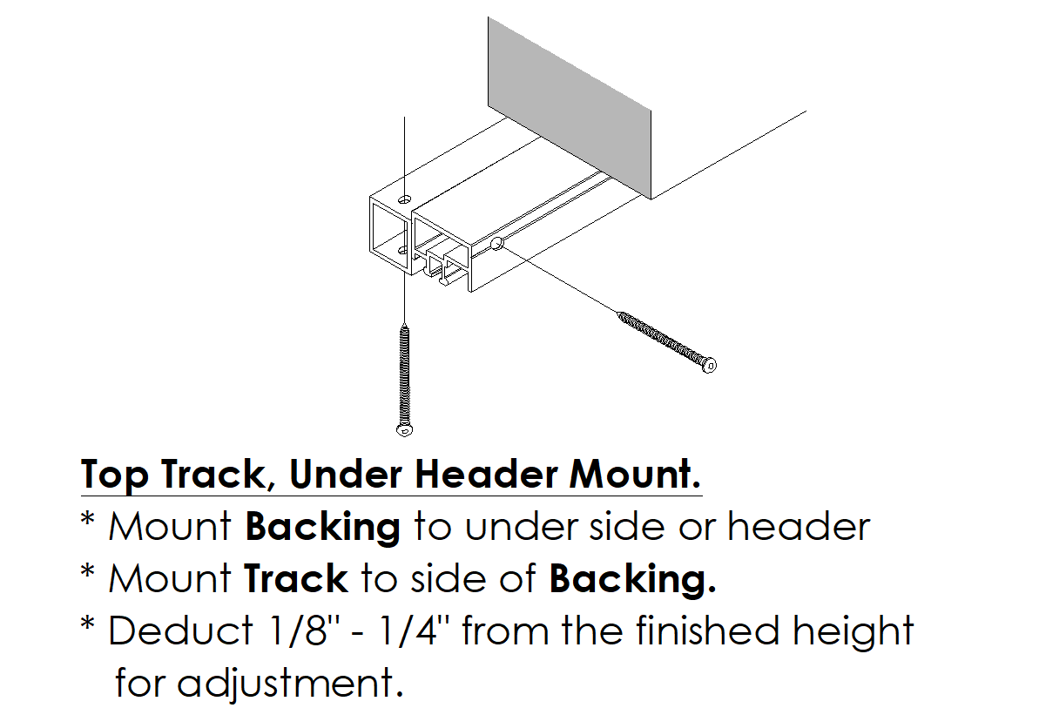
- “In-Jamb” installs – If installing in-jamb/under header, you should not screw the top track upwards into the header. Instead, you should install a 1”x1” backing (Mirage has these) under the header, and then horizontally fasten the top track to the backing. This enables for slight adjustment of the top track height across the opening, to ensure the screen runs smoothly along the tracks (see image at right).

Also, the bottom track should not be screwed downwards – it should be secured horizontally into a backing or the Mirage 3500 Ramp System.

Important:
- Detailed install videos for the Mirage 3500 can be found at:
  - https://miragescreensystems.com/video-training-library/
- For further assistance, Mirage head office # is 1-855-488-7655.

